Exercise 23-7-2020

* Design another page to list out favorite movies and link to different page using iframe and sectionize page to display interesting quotes on a center of a page. Include image in the background.
* Create a webpage having train source and destination details in a table with an appropriate span, padding and heading.
* Write HTML Frameset code

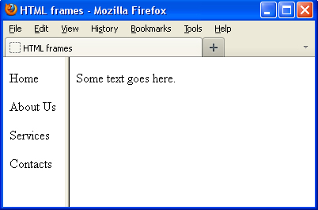

1.html

<html>

<frameset rows="20%,80%">

<frame name=f1 src=menu.html>

<frame name=f2 src=c1.html>

</frameset>

</html>

Menu.html

<html>

<ahref="content.html" target=f2>html</a>

</html>

C1.html

<html>

Welcome

</html>

Content.html

<html>

<p> HTML</p>

<ol>

<li> basic tags</li>

<li> hyperlink</li>

<li> imagemap</li>

<li> table</li>

</ol>

</html>